

SALESFORCE PROJECT READY

ENTRY LEVEL TRAINING & PROFESSIONAL DEVELOPMENT PROGRAM

PROJECT TITLE: COLLEGE MANAGEMENT SYSTEM



**Day 1 :**

Topic: Create your salesforce developer org to get started

Milestone / Activities: login in salesforce account

Detailed Description:

1.Go to salesforce.com and click on login.

2.Enter the username and password that you just created.

3.After login this is the home page which you will see.

Upload the Screenshot the Milestone / Activities :

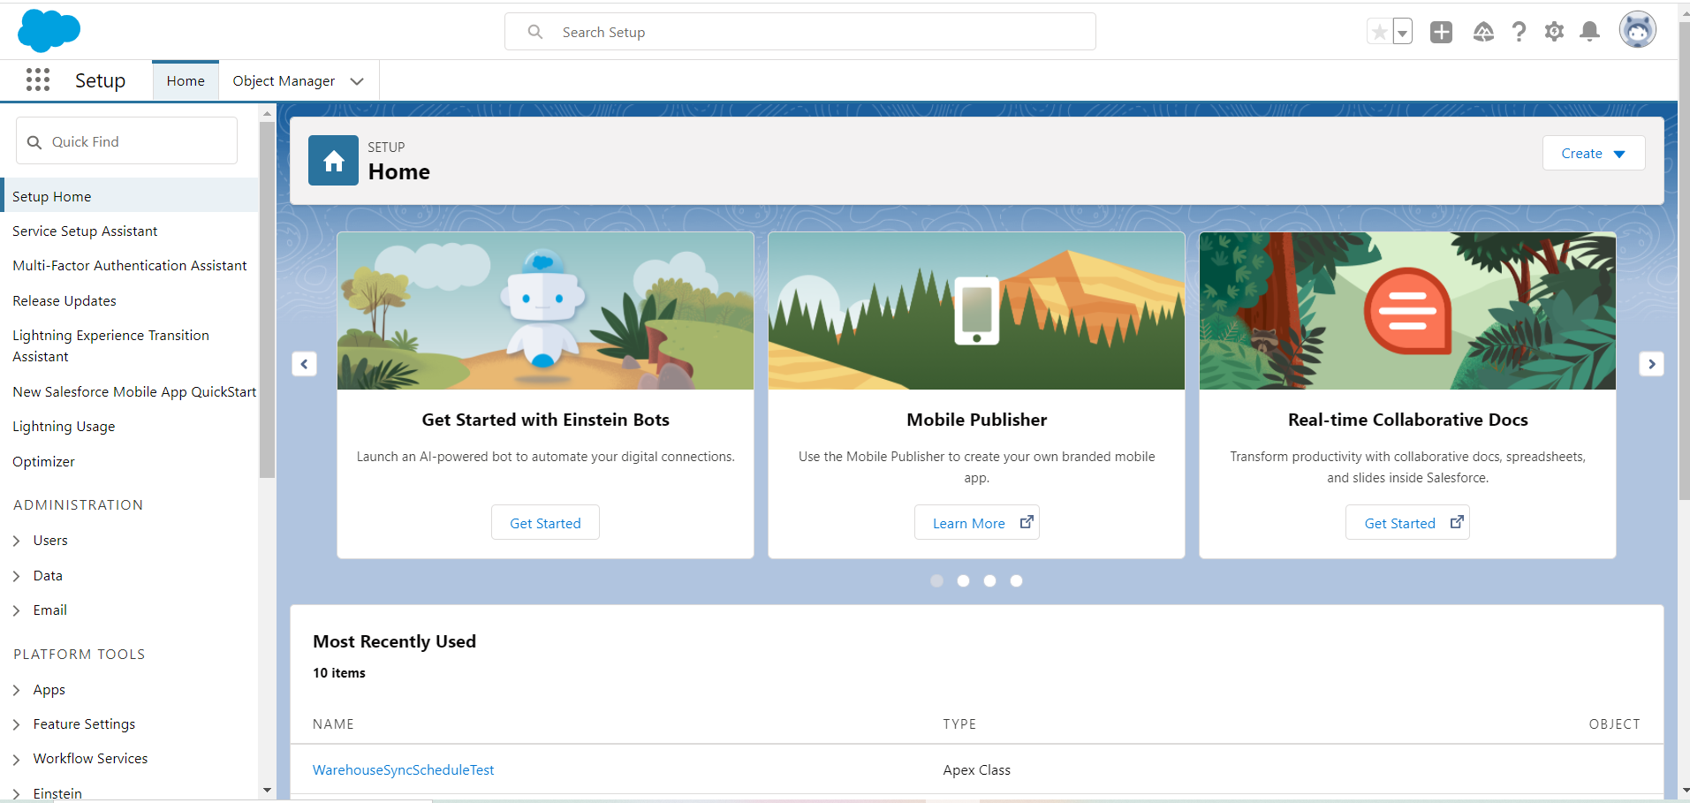

**Day 2 :**

Topic:

Milestone / Activities:

Detailed Description:

Upload the Screenshot the Milestone / Activities :

**Day 3 :**

Topic:

Milestone / Activities:

Detailed Description:

Upload the Screenshot the Milestone / Activities :



**Day 4 :**

Topic:

Milestone / Activities:

Detailed Description:

Upload the Screenshot the Milestone / Activities :

**Day 5 :**

Topic:

Milestone / Activities:

Detailed Description:

Upload the Screenshot the Milestone / Activities :

**Day 6 :**

Topic:

Milestone / Activities:

Detailed Description:

Upload the Screenshot the Milestone / Activities :



**Day 7 :**

Topic:

Milestone / Activities:

Detailed Description:

Upload the Screenshot the Milestone / Activities :

**Day 8 :**

Topic:

Milestone / Activities:

Detailed Description:

Upload the Screenshot the Milestone / Activities :

**Day 9 :**

Topic:

Milestone / Activities:

Detailed Description:

Upload the Screenshot the Milestone / Activities :



**Day 10 :**

Topic:

Milestone / Activities:

Detailed Description:

Upload the Screenshot the Milestone / Activities :

**Day 11 :**

Topic:

Milestone / Activities:

Detailed Description:

Upload the Screenshot the Milestone / Activities :

**Day 12 :**

Topic:

Milestone / Activities:

Detailed Description:

Upload the Screenshot the Milestone / Activities :

